Tables and figures https://rpubs.com/marcelo-araya-salas/1004658

Table 1 Selected soil chemical (0-10 cm depth) and vegetation properties of fertilization treatments at EARTH University forest reserve in Limón, Costa Rica. Treatments consist of a control, nitrogen (+N), phosphorus (+P), and nitrogen and phosphorus (+NP) addition. The last two columns represent the results of a factorial one-way ANOVA, with F and p-values shown. Different letters denote significant differences across treatment levels, as indicated by Tukey’s h.s.d. n. Data from Vincent et al. (in prep.).

 | Fertilization | treatment
Variable | Control | +N | +P | +NP | F | p
Soil pH_{H20} | 4.2 (0.1)a | 4.0 (0.1)b | 4.2 (0.1)a | 4.2 (0.1)a | 5.72 | 0.006
PO₄⁻ (μg g⁻¹) ª | 3.2 (2.2)a | 3.3 (4.4)a | 45 (32.4)b | 46 (9.7)b | 7.50 | 0.002
NO₃⁻ (μg g⁻¹) ^{c} | 10.6 (0.6) | 14.5 (1.6) | 9.3 (1.3) | 10.5 (1.8) | 2.18 | 0.126
Total C (g kg⁻¹) | 45.5 (1.83) | 47.0 (2.43) | 45.0 (1.26) | 47.9 (3.30) | 0.47 | 0.706
Total N (g kg⁻¹) | 3.99 (0.20) | 4.07 (0.18) | 3.96 (0.11) | 4.06 (0.25) | 0.24 | 0.869
Total P (g kg⁻¹) ª | 1.65 (0.25) ª | 1.38 (0.13) | 1.87 (0.20) | 1.94 (0.18) | 0.95 | 0.440
Trees that grew (%)^{b} | 66.3 (4.6) | 66.6 (1.9) | 76.8 (3.7) | 77.0 (3.4)
Litterfall production (Mg ha⁻¹) | 4.61 (0.5) | 4.72 (0.3) | 5.28 (0.8) | 4.43 (0.7)

ª Extractable in water with anion-exchange resins, and excluding control plot 19 due to anomalously (but presumed natural) high P concentrations.
^{b} Percentage of trees in each plot that had growth 2.7 years after the start of the experiment.

Table 2 Effect of fertilization treatment on litter and wood mass loss and on litter nutrient content, as determined by Bayesian generalized linear mixed models. Effect sizes are relative to the control and are presented as median posterior estimates. Additionally, 95% credibility intervals are presented as the highest posterior density interval. Parameters in which credible intervals did not include zero were regarded as affecting the response variable, and are marked in bold.
Response variable | Treatment vs. control | Effect size | Rhat | Bulk ESS | Lower CI | Higher CI
Litter mass | +N | -0.040 | 1.001 | 5690.177 | -0.208 | 0.121
remaining (%) | +P | 0.029 | 1.001 | 5974.909 | -0.132 | 0.190
 | +NP | 0.072 | 1.001 | 5573.670 | -0.092 | 0.228
 | Days | -0.684 | 1.001 | 4616.778 | -0.802 | -0.572
 | treatN:days | -0.046 | 1 | 5998.249 | -0.204 | 0.112
 | treatNP:days | 0.107 | 1 | 6006.594 | -0.043 | 0.261
 | treatP:days | 0.057 | 1 | 5653.754 | -0.096 | 0.214
Wood mass | +N | 0.117 | 1 | 6570.847 | -0.126 | 0.354
remaining (%) | +P | 0.196 | 1 | 5894.173 | -0.050 | 0.440
 | +NP | 0.252 | 1 | 6650.325 | 0.003 | 0.497
 | Days | -0.911 | 1.001 | 4669.648 | -1.097 | -0.735
 | treatN:days | -0.005 | 1 | 5914.903 | -0.241 | 0.236
 | treatNP:days | 0.098 | 1.001 | 5559.877 | -0.139 | 0.341
 | treatP:days | 0.176 | 1.001 | 5569.761 | -0.058 | 0.418
Litter N content | +N | −0.339 | 1.001 | 7623.531 | −0.636 | −0.056
(% initial) | +P | −0.057 | 1 | 7553.928 | −0.342 | 0.227
 | +NP | −0.047 | 1 | 7184.793 | −0.335 | 0.244
 | Days | -0.502 | 1.001 | 4864.519 | -0.705 | -0.304
 | treatN:days | -0.095 | 1 | 6426.103 | -0.367 | 0.181
 | treatNP:days | 0.038 | 1 | 5969.146 | -0.233 | 0.303
 | treatP:days | 0.048 | 1.001 | 6218.352 | -0.225 | 0.313
Litter P content | +N | −0.430 | 1 | 4571.772 | −0.940 | 0.050ª
(% initial) | +P | 0.155 | 1.001 | 4681.294 | −0.369 | 0.671
 | +NP | 0.025 | 1.001 | 4609.206 | −0.467 | 0.496
 | Days | -0.609 | 1.001 | 4940.488 | -0.865 | -0.364
 | treatN:days | -0.046 | 1 | 6137.326 | -0.408 | 0.312
 | treatNP:days | 0.135 | 1.001 | 5979.456 | -0.210 | 0.465
 | treatP:days | -0.075 | 1.001 | 6078.993 | -0.456 | 0.299

ª Marginally affects the response variable. All had 5000 iterations and 4 chains.
Fig. 1 Location of fertilization plots in the EARTH forest reserve in Limon, Costa Rica. There are only four +N fertilization plots because two were destroyed by treefall during a storm.
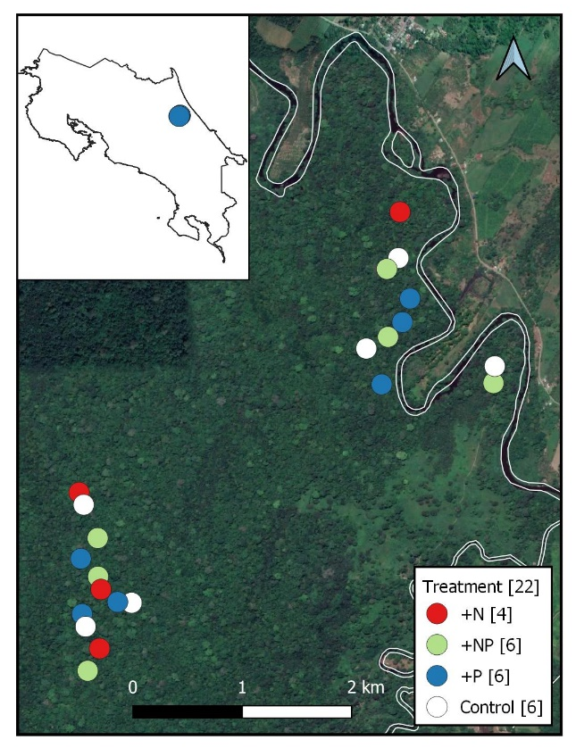

Fig. 2 Average monthly precipitation (blue bars) and air temperature (red line) at EARTH University in Limón, Costa Rica, for 1996−2018. See Methods for a description of missing data.

Fig. 3 Remaining mass (% of initial) as a function of time for (a) Hyeronima alchorneoides leaf litter and (b) birch wood sticks, set to decompose for 36 weeks in long-term forest fertilization plots (n=16) at the Earth Forest Fertilization Experiment in Limón, Costa Rica; values shown are means per plot (n=4) ± S.E.
Hola, falta este plot combinado, no está en RPubs

a | b
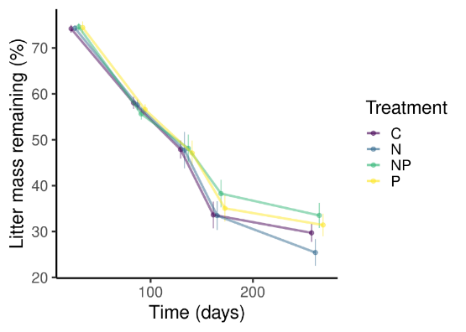 | 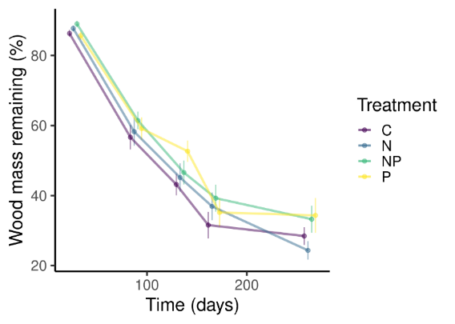

Fig. 4 Violin plots showing values of the decomposition constant (k), for Hyeronima alchorneoides leaf litter (a,c) and soft wood (b,d) that decomposed for 36 weeks and was subjected to the effects of phosphorus (a, b) and nitrogen (c, d) addition at the EARTH University forest reserve in Limón, Costa Rica. ESTOS GRÁFICOS SON PARA MADERA, FALTAN LOS DE LITTER. FALTA COMBINARLOS EN UNA SOLA FIGURA. TAL VEZ SE PUEDEN COMBINAR CON PAR MFROW O ALGO? MARCELO CÓMO SE LLAMAN ESTOS GRÁFICOS Y QUÉ INFORMACIÓN ADICIONAL BRINDA EL SOMBREADO DE LA DERECHA QUE NO LA DAN YA LOS PUNTOS DE LA IZQUIERDA? NO ENTIENDO MUY BIEN CÓMO SE INTERPRETA ESE SOMBREADO…
a | b
 | 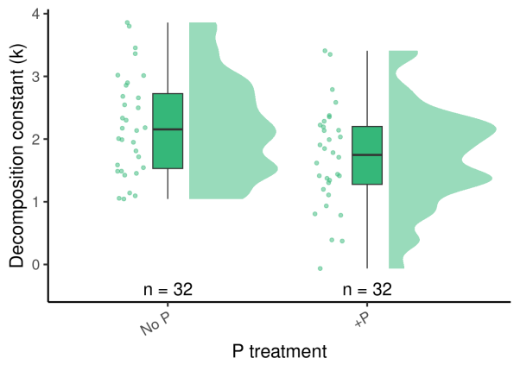
c | d
 | 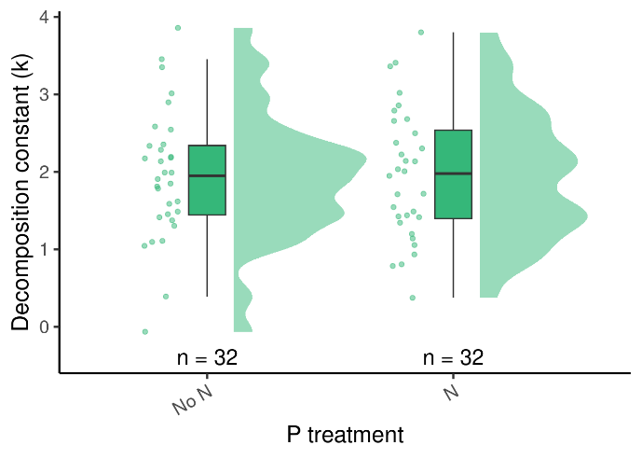

Fig. 5 Hyeronima alchorneoides leaf litter (a) nitrogen and (b) phosphorus content (% of initial amount remaining) through a 36-week decomposition study at the EFFEX fertilization experiment in Limón, Costa Rica.
a | b
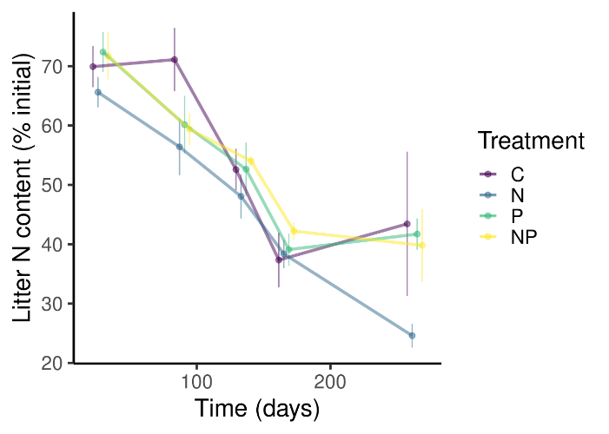 | 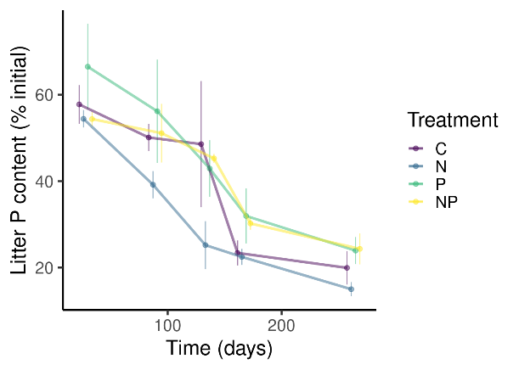

Gráfico nuevo:
- Debería decir “Litter nutrient content (% initial)” en el eje Y, no “Nutrient ratios”
- Se pueden hacer las escalas del eje Y iguales? 20, 40, 60 para ambos
- La caja donde dice N y P está como corrida para la derecha en relación al eje Y, se puede alinear?
- Se puede aumentar la altura del gráfico para apreciar mejor diferencias entre tratamientos?

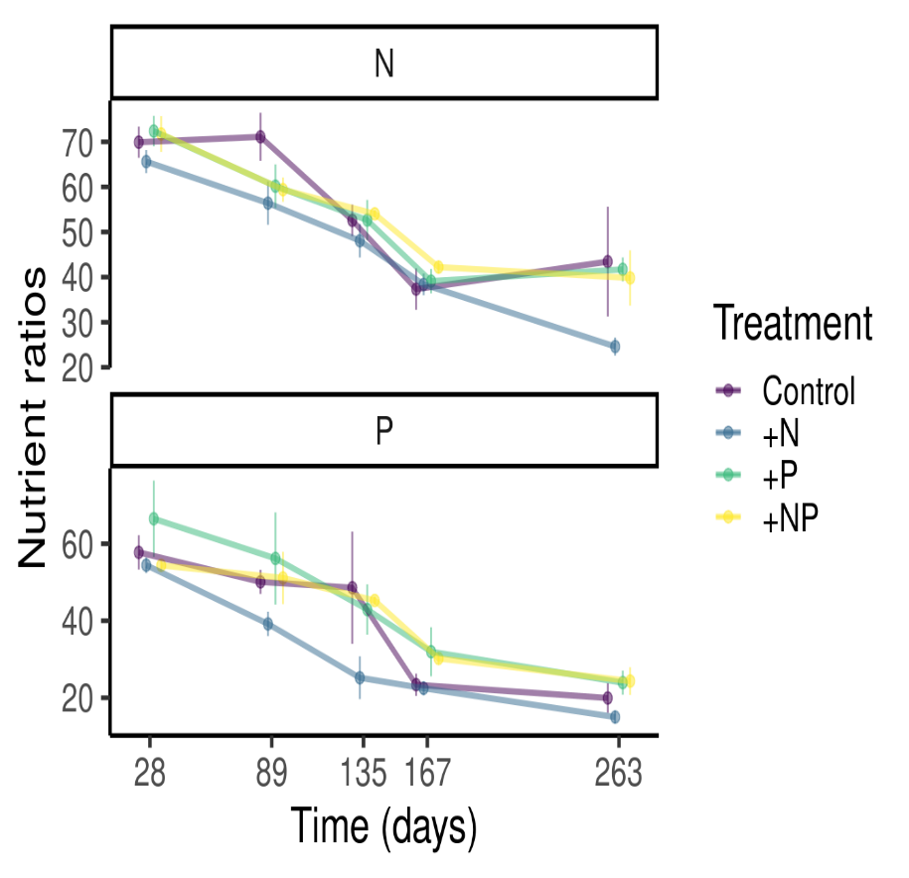

Supplementary Tables and Figures

Table S1 Model output of a Bayesian generalized linear mixed effects model testing the effect of fertilization treatment, time, and their interaction on litter nitrogen and phosphorus concentration. Effect sizes are relative to the control and are presented as median posterior estimates. The 95% credibility intervals are presented as the highest posterior density interval. Parameters in which credible intervals did not include zero were regarded as affecting the response variable, and are marked in bold.

Variable | Treatment | Estimate | Rhat | Bulk_ESS | CI_low | CI_high
Litter N | TreatN | -0.097 | 1.001 | 7474.291 | -0.240 | 0.048
concentration (%) | TreatNP | -0.052 | 1.001 | 8070.802 | -0.194 | 0.087
 | TreatP | -0.024 | 1 | 8472.181 | -0.160 | 0.115
 | Days | 0.133 | 1 | 5929.138 | 0.037 | 0.227
 | TreatN:days | -0.076 | 1 | 6586.061 | -0.206 | 0.056
 | TreatNP:days | -0.030 | 1 | 7153.092 | -0.161 | 0.104
 | TreatP:days | -0.011 | 1 | 6648.487 | -0.135 | 0.118
Litter P | TreatN | -0.108 | 1 | 9047.006 | -0.625 | 0.401
concentration (%) | TreatNP | 0.030 | 1 | 9297.820 | -0.488 | 0.524
 | TreatP | 0.078 | 1.001 | 9678.162 | -0.456 | 0.611
 | Days | -0.032 | 1 | 6266.542 | -0.383 | 0.309
 | TreatN:days | -0.003 | 1 | 7398.313 | -0.492 | 0.481
 | TreatNP:days | 0.037 | 1 | 7705.990 | -0.423 | 0.502
 | TreatP:days | 0.027 | 1 | 7949.040 | -0.476 | 0.525

Table S2 Model output of a Bayesian generalized linear mixed effects model testing the effect of fertilization treatment, time, and their interaction on Hyeronima alchorneoides leaf litter C:N, N:P, and C:P ratios (molar basis). Effect sizes are relative to the control and are presented as median posterior estimates. The 95% credibility intervals are presented as the highest posterior density interval. Parameters in which credible intervals did not include zero were regarded as affecting the response variable, and are marked in bold.
Variable | Treatment | Estimate | Rhat | Bulk_ESS | CI_low | CI_high
Litter C:N | treatN | 0.313 | 1 | 7842.521 | -1.353 | 2.024
 | treatNP | -0.196 | 1 | 7685.104 | -1.853 | 1.453
 | treatP | -0.191 | 1.001 | 6847.894 | -1.861 | 1.438
 | Days | -3.106 | 1 | 5734.258 | -4.192 | -1.997
 | treatN:days | 0.754 | 1 | 7204.545 | -0.744 | 2.225
 | treatNP:days | 0.449 | 1.001 | 7147.178 | -1.090 | 1.980
 | treatP:days | 0.116 | 1.001 | 7099.674 | -1.359 | 1.623
Litter N:P | treatN | 1.096 | 1 | 5365.525 | -3.525 | 5.540
 | treatNP | -2.609 | 1.001 | 5225.316 | -7.064 | 1.807
 | treatP | -3.399 | 1.001 | 5000.731 | -8.069 | 1.269
 | days | 4.565 | 1 | 5192.835 | 1.799 | 7.301
 | treatN:days | -1.984 | 1 | 6608.766 | -5.780 | 1.818
 | treatNP:days | -1.964 | 1 | 6512.378 | -5.690 | 1.773
 | treatP:days | -1.606 | 1 | 6638.446 | -5.605 | 2.386
Litter C:P | treatN | 39.096 | 1.001 | 5150.560 | -40.777 | 118.666
 | treatNP | -54.501 | 1.001 | 5029.933 | -135.193 | 25.065
 | treatP | -72.372 | 1 | 5570.416 | -157.584 | 14.177
 | Days | 2.198 | 1.001 | 4239.965 | -45.167 | 49.569
 | treatN:days | -6.611 | 1 | 5083.811 | -71.740 | 56.616
 | treatNP:days | -35.577 | 1 | 5382.098 | -100.957 | 27.107
 | treatP:days | -27.367 | 1 | 5706.847 | -97.766 | 41.870

Fig. S1 Changes in the concentration (%) of (a) nitrogen and (b) phosphorus in Hyeronima alchorneoides decaying litterfall (mean ± standard error) over a 36-week period decomposition study at the EARTH Forest Fertilization Experiment in Limón, Costa Rica.
a | b
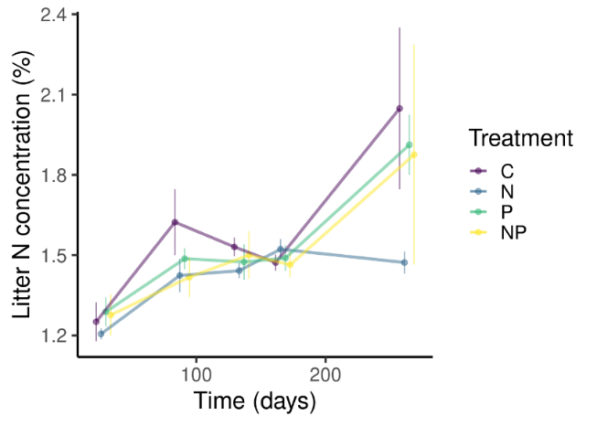 | 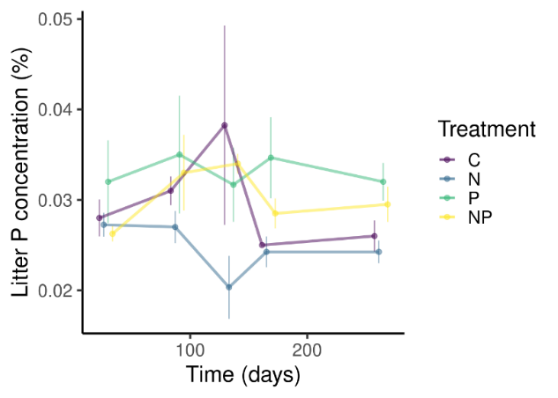

Gráfico nuevo
- Eje Y debería decir “Litter nutrient concentration (%)” en vez de “Litter content (%)”
- La caja donde dice N y P está como corrida para la derecha en relación al eje Y, se puede alinear?
- Se puede aumentar la altura del gráfico para apreciar mejor diferencias entre tratamientos?

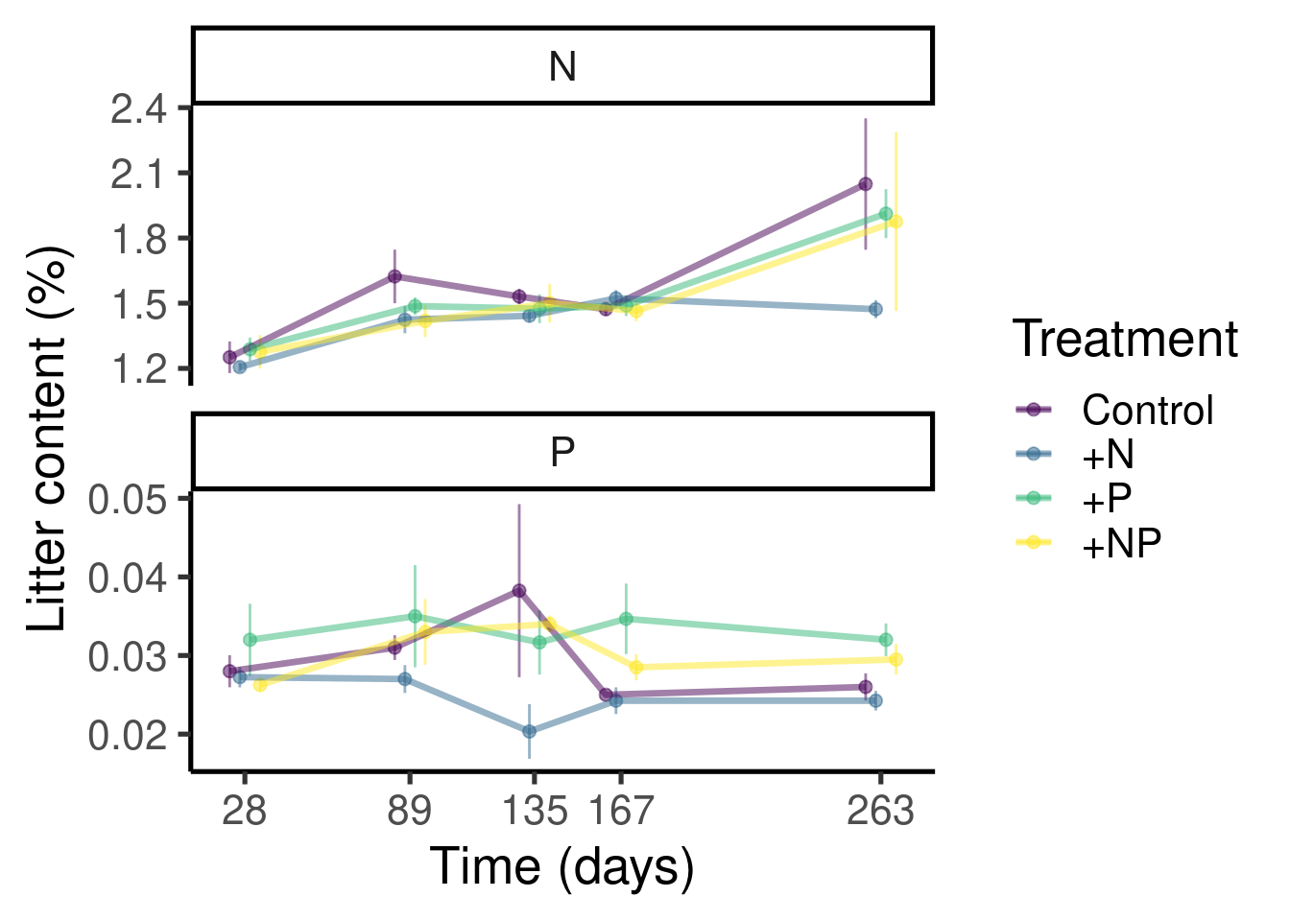

Fig. S2 Molar ratios of (a) carbon to nitrogen, (b) nitrogen to phosphorus, and (c) carbon to phosphorus in Hyeronima alchorneoides leaf litter during a 36-week decomposition study in a long-term forest fertilization experiment in Limón, Costa Rica.
a
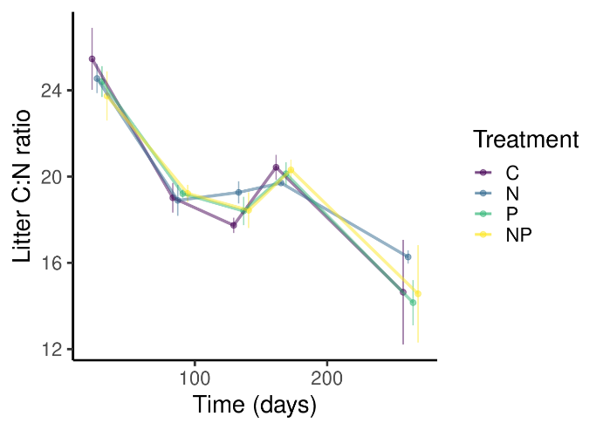
b
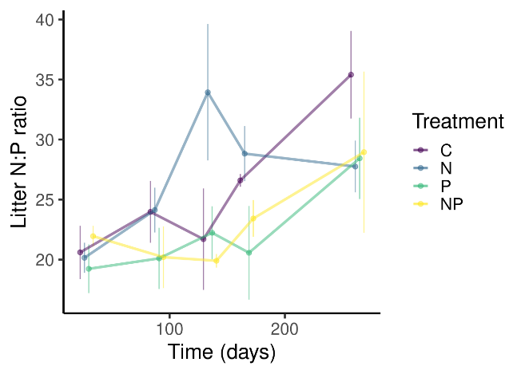
c
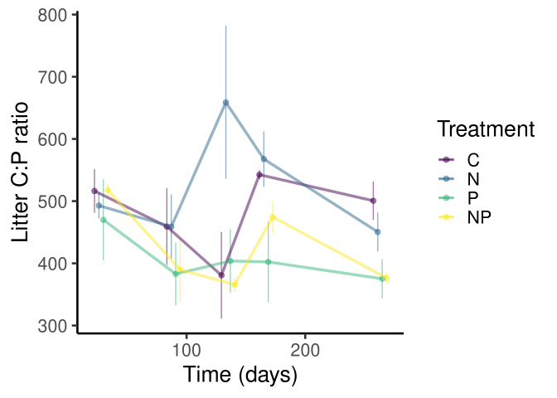

Gráfico nuevo
- Eje Y debería decir “Litter nutrient ratios” en vez de “Litter content (%)”
- La caja donde dice C:N, C:P y N:P está como corrida para la derecha en relación al eje Y
- Se puede aumentar un poco la altura del gráfico para apreciar mejor diferencias entre tratamientos? Y de paso que no estén tan juntos los números del eye Y.

